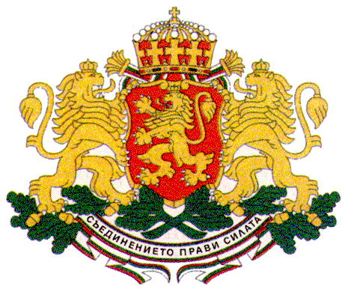 | PERMANENT MISSION OF THE REPUBLIC OF  BULGARIA  TO THE UNITED NATIONS

11 East 84th Street, New York, NY 10028, Tel: (212) 737 4790, Fax: (212) 472 9865, e-mail: bulgaria@un.int

UNICEF Executive Board
2015 Annual Session, New York, 16 – 18 June 2015

H.E. Mr. Stephan Tafrov, Ambassador,
Permanent Representative of Bulgaria to the UN

General Statements

New York, Tuesday, 16 June 2015

Madam President,
I would like to commend the Executive Director Mr. Anthony Lake for his exemplary leadership, strong commitment and tireless efforts in advancing children’s rights all over the world and to thank him for a very comprehensive and informative annual report.
This is the first annual report of the Executive Director since the launch in 2014 of the new UNICEF Strategic Plan for the period 2014 – 2017 and of the Gender Action Plan.
The annual report marks also the first fifth year cycle since the announcement in 2010 of the equity refocus of UNICEF’s work and the orientation of all programmes, operations and partnerships towards ensuring a fair chance in life for every child.
Bulgaria welcomes the improved results for children in the last five years, especially as regards the most disadvantaged and marginalized groups.
Madam President,
Bulgaria commends UNICEF for successfully fulfilling its humanitarian mandate as well considering the unprecedented scale of humanitarian crises in 2014 and the particular vulnerability of children, including the persistence of conflicts in many parts of the world, natural disasters and epidemics. UNICEF did an outstanding work as regards the Ebola outbreak.
The situation of children in Nepal after the recent devastating earthquakes remains a major concern. Bulgaria joined the efforts of the international community in supporting the people of Nepal with humanitarian assistance through UNICEF and other social partners, as well as through a number of money raising campaigns.
Here, I would like to pay tribute to all UNICEF staff members who have lost their lives in the noble cause of children, most recently in Somalia. Their lives and mission are valued and appreciated and they will always be remembered as true heroes.
Madam President,
The Government of Bulgaria attaches great importance to the protection of children and the promotion of their rights which is a main priority on my country’s human rights agenda. All Government policies and programmes related to children follow a human-rights-based approach being designed in the best interest of children.
UNICEF Bulgaria is a valuable partner in all major national initiatives concerning children and is an important factor for achieving real and durable results for the well-being of children in Bulgaria. The long-standing cooperation with UNICEF is instrumental in all processes related to the formulation, implementation and monitoring of child policies and programmes, as well as in capacity building and probating new models and approaches for the promotion of child welfare. UNICEF has played a crucial role also for the establishment of the fruitful partnership with the civil society, media and other social partners for advancing the children’s agenda in my country.
Ending violence against children is a main priority for Bulgaria. The Government works closely with UNICEF on a number of social campaigns, including “End Violence”, “Making the Invisible Visible”, “Imagine”, etc., aimed at raising awareness in the society about the scope and dimensions of the problem in order to prevent it from happening and to deal successfully with the consequences by helping and supporting the victims and bringing to justice the perpetrators.
In 2012 the Ministry of Education and Science together with other government institutions, UNICEF, social partners and the civil society developed a set of special measures for countering bullying and harassment in schools which was adopted as national guidelines for all schools in the country.
The Bulgarian Government attaches great importance also to the promotion of inclusive education and takes the necessary measures for ensuring equal access to education for all, including children and youth with special needs.
In March 2015 UNICEF Bulgaria launched a social campaign for promoting the right of child participation with the aim to encourage an informed inclusion of children of different ages, social status and ethnic background in all processes that affect their lives. The first ever direct and large-scale online consultation with children entitled “My Voice Matters” was conducted as part of the campaign and covered topics of great public concern such as education, healthcare, social security, leisure activities, etc. In April 2015 UNICEF Bulgaria together with the State Agency for Child Protection convened a meeting in Sofia with children and youth from different parts of Bulgaria in which I also had the pleasure to participate. The meeting gave us the opportunity to interact directly with more than 30 children and to hear their opinion and proposals as regards family, education, social security, leisure activities, the right to opinion. As main challenges in their lives the children identified poverty, poor quality education, bullying in schools, violence, easy access to drugs, cigarettes and alcohol.
The results of those consultations with children will be taken into consideration by the National Assembly of Bulgaria, the Council of Ministers and the State Agency for Child Protection when updating the National Strategy for the Child.
Madam President,
With the post-2015 negotiations entering their final and crucial stage, as a co-chair of the Group of Friends of Children and SDGs Bulgaria together with UNICEF and other partners continues to actively advocate for integrating children’s human rights in all aspects of development with the firm conviction that children should be at the heart of the post-2015 development agenda.
To conclude, I would like to reiterate the support of my country to the work of UNICEF and the high appreciation to UNICEF’s management and staff for their firm commitment and dedication to protecting children and advancing the rights of every child everywhere in the world.
Bulgaria highly values its strong partnership with UNICEF and looks forward to further strengthening and expanding it and raising it to a qualitatively new level in the best interest of children.

Thank you, Madam President.

